EXPERIMENT 7 — GROUP BY, HAVING and ORDER BY
AIM:
To study and execute GROUP BY, HAVING, and ORDER BY clauses for grouping, filtering, and sorting records.
PROCEDURE:
- Display all vehicle records.
- Group vehicles according to fuel type.
- Find the number of vehicles for each fuel type.
- Calculate the average and total price for each fuel type.
- Use HAVING to filter grouped results.
- Sort vehicles by price in ascending order.
- Sort vehicles by price in descending order.
- Sort vehicles alphabetically by vehicle name.
- Combine GROUP BY, HAVING, and ORDER BY in a single query.
OUT: 1
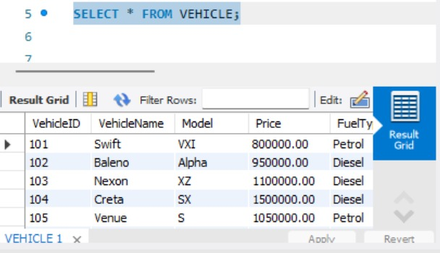
OUT: 2
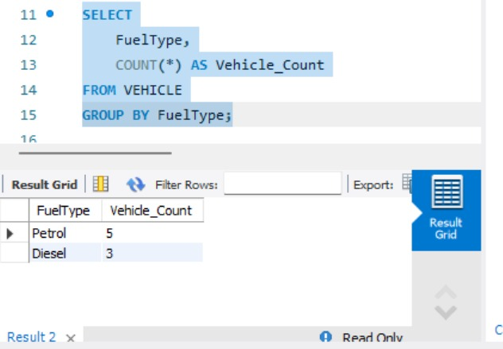
OUT: 3
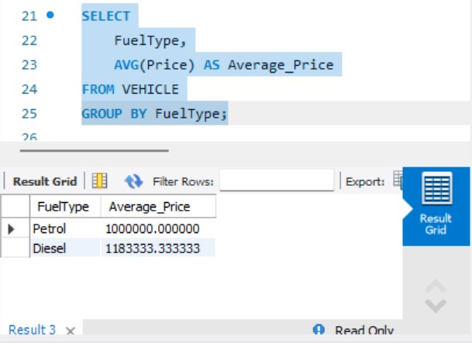
OUT: 4
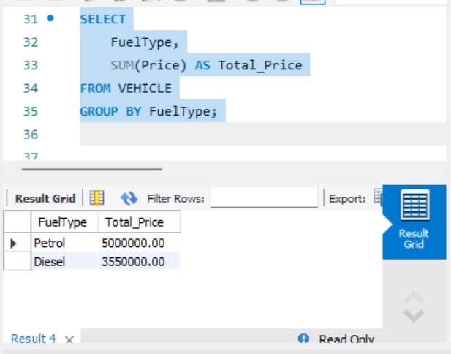
OUT : 5
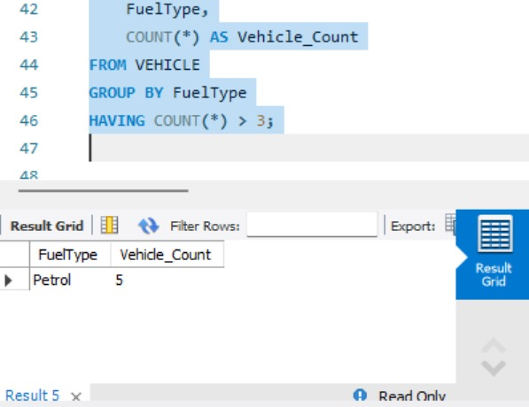
OUT : 6
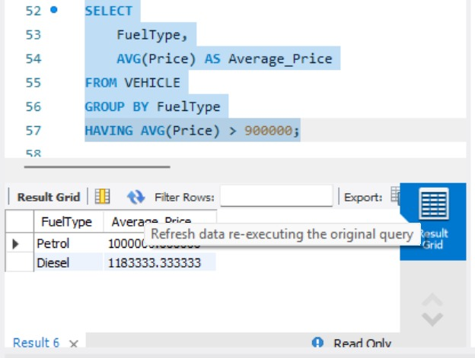
OUT : 7
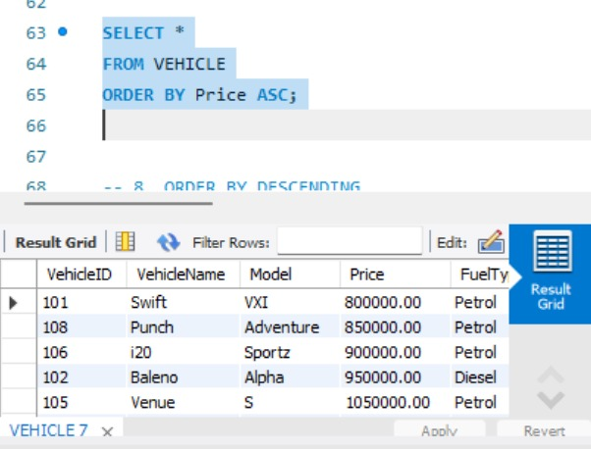
OUT : 8
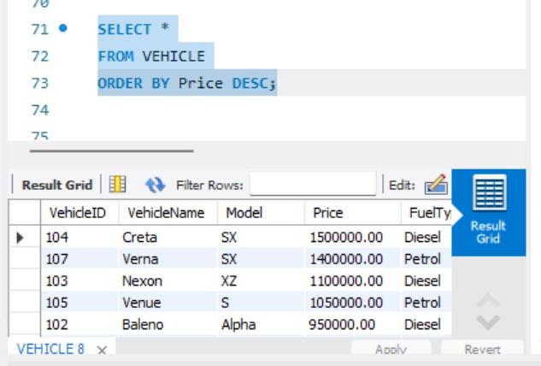
OUT : 9
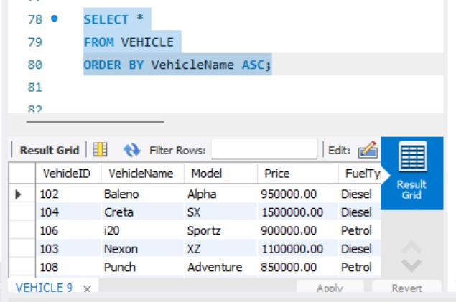
OUT : 10
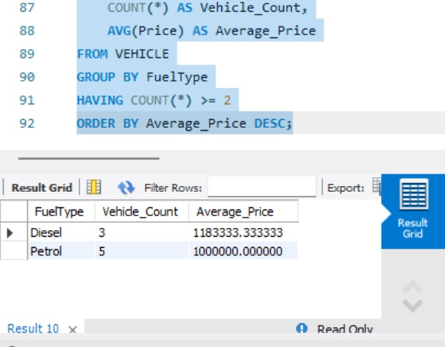
QUERY:
USE AUTOHUB_SHOWROOM;
-- 1. DISPLAY ALL VEHICLES
SELECT * FROM VEHICLE;
-- 2. GROUP BY FUEL TYPE
-- Count vehicles based on fuel type
SELECT
FuelType,
COUNT(*) AS Vehicle_Count
FROM VEHICLE
GROUP BY FuelType;
-- 3. GROUP BY FUEL TYPE
-- Find average price for each fuel type
SELECT
FuelType,
AVG(Price) AS Average_Price
FROM VEHICLE
GROUP BY FuelType;
-- 4. GROUP BY FUEL TYPE
-- Find total price for each fuel type
SELECT
FuelType,
SUM(Price) AS Total_Price
FROM VEHICLE
GROUP BY FuelType;
-- 5. HAVING
-- Display fuel types having more than 3 vehicles
SELECT
FuelType,
COUNT(*) AS Vehicle_Count
FROM VEHICLE
GROUP BY FuelType
HAVING COUNT(*) > 3;
-- 6. HAVING
-- Display fuel types whose average price is greater than 900000
SELECT
FuelType,
AVG(Price) AS Average_Price
FROM VEHICLE
GROUP BY FuelType
HAVING AVG(Price) > 900000;
-- 7. ORDER BY ASCENDING
-- Display vehicles from lowest price to highest price
SELECT *
FROM VEHICLE
ORDER BY Price ASC;
-- 8. ORDER BY DESCENDING
-- Display vehicles from highest price to lowest price
SELECT *
FROM VEHICLE
ORDER BY Price DESC;
-- 9. ORDER BY VEHICLE NAME
SELECT *
FROM VEHICLE
ORDER BY VehicleName ASC;
-- 10. GROUP BY + HAVING + ORDER BY
SELECT
FuelType,
COUNT(*) AS Vehicle_Count,
AVG(Price) AS Average_Price
FROM VEHICLE
GROUP BY FuelType
HAVING COUNT(*) >= 2
ORDER BY Average_Price DESC;

RESULT:
Thus, the GROUP BY, HAVING, and ORDER BY clauses were successfully executed for grouping, filtering, and sorting vehicle data.

